
Session: 2022-23
------------------------------------------------------------
A PROJECT REPORT ON
The ultimate Manager
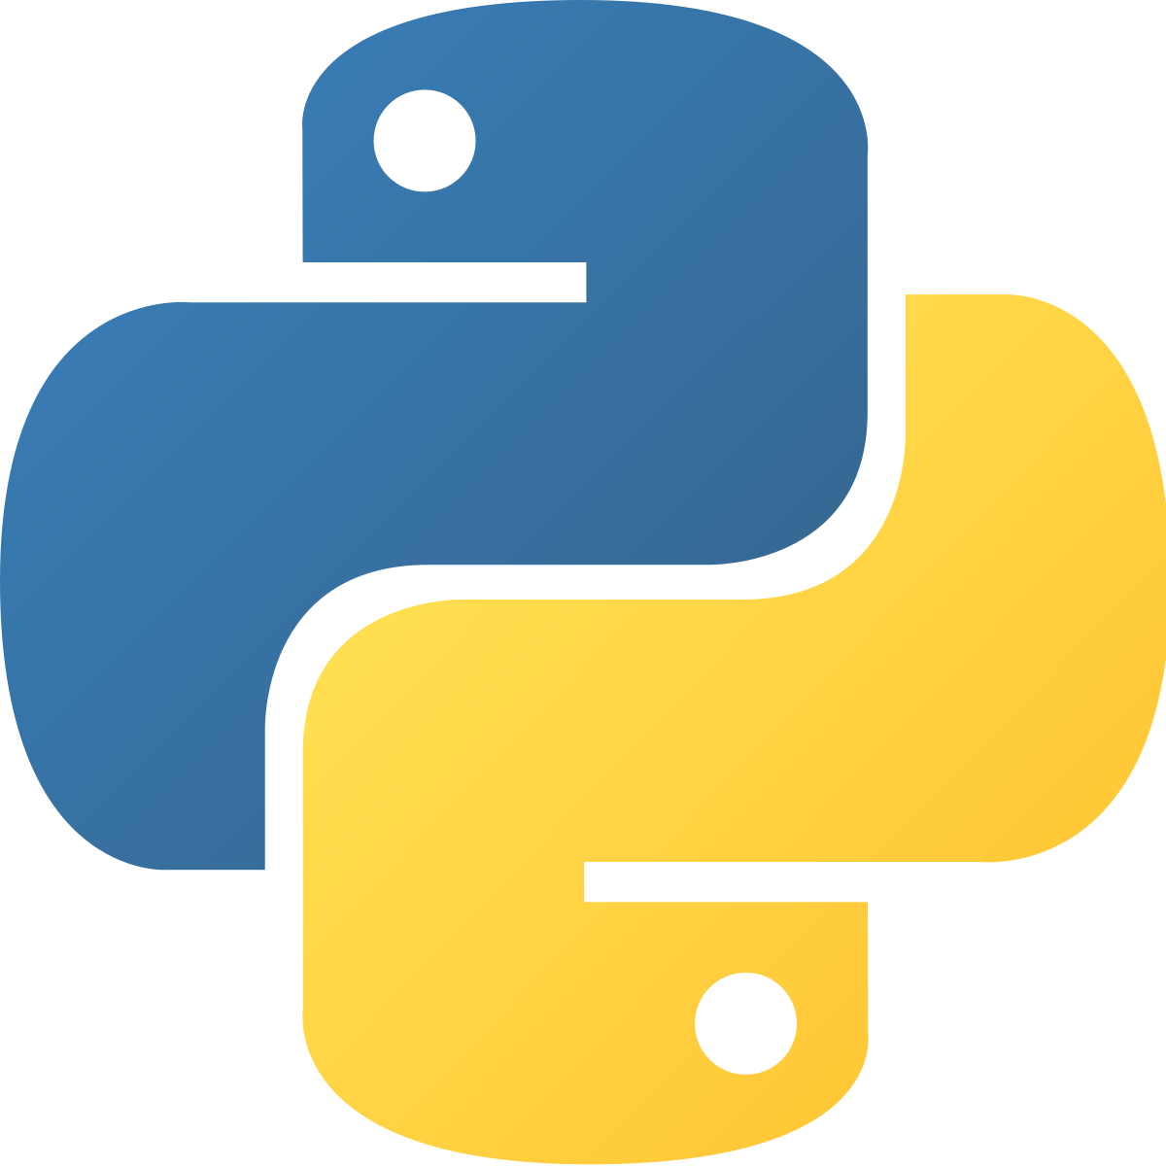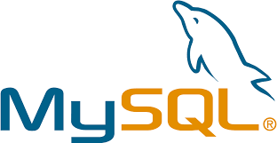

Submitted to submitted by:
mr. Nadeem Sir Atharv Agarwal
(COMPUTER SCIENCE DEPARTMENT) XIi – H
2009/0235
CERTIFICATE

This is to certify that Atharv Agarwal of class XII H, Session 2022-23 of Delhi Public School Ranipur has done his/her project on “The Ultimate Manager” under my supervision. He/She has taken interest and has shown at most sincerity in completion of this project.
I certify this Project up to my expectation and as per guidelines issued by CBSE, NEW DELHI.

Internal Examiner External Examiner

Principal

aCKNOWLEDGMENT

It is with pleasure that I acknowledge my sincere gratitude to our teacher, Mr. Nadeem who taught and undertook the responsibility of teaching the subject computer science. I have been greatly benefited from his classes.
I am especially indebted to our Principal Mr. Anupam Jagga who has always been a source of encouragement and support and without whose inspiration this project would not have been a successful I would like to place on record heartfelt thanks to him.
Finally, I would like to express my sincere appreciation for all the other students for my batch their friendship & the fine times that we all shared together.

Index
S.NO | Topic | Page No. | Teacher’s Signature
 | Introduction to Python | 4
 | Features of Python | 4 – 5
 | Introduction to MySQL | 6
 | Introduction to MySQL-Python Connectivity | 6
 | Establishing Connectivity | 6
 | About the Project | 7
 | Explanation | 8-9
 | Coding | 10-15
 | Output and Execution | 16-21
 | Technology Used | 22
 | Bibliography | 23

Introduction to Python
Python is a popular programming language. It was created by Guido van Rossum, and released in 1991.

It is used for:
- Web Development (server-side),
- Software development
- Mathematics
- System scripting

Features Of Python

Python has several features. Some of most popular and powerful features are listed below:

- Easy:
- Easy to Code
Python is very easy to code as compared to other popular languages like Java and C++.
B) Easy to Read
Being a high-level language, Python code is quite like English. Looking at it, you can tell what the code is supposed to do. Also, since it is dynamically-typed, it mandates indentation. This aids readability

- Expressive:
Python provides us with a myriad of constructs that help us focus on the solution rather than on the syntax.
- Free & Open source:
Firstly, Python is freely available. You can download it from the Python Official Website.
Secondly, it is open-source. This means that its source code is available to the public. You can download it, change it, use it, and distribute it.
- High Level:
Python is a high-level language. This means that as programmers, we don’t need to remember the system architecture. Also, we need not manage memory. This makes it more programmer-friendly and is one of the key python features.

- Potable:
You can take one code and run it on any machine. This makes Python a portable language. However, you must avoid any system-dependent features in this case.

Introduction to MySQL
MySQL is an open-source, fast reliable, and flexible relational database management system.

- Features of MySQL:
- MySQL server design is multi-layered with independent modules.
- MySQL provides transactional and non-transactional storage engines.
- MySQL has a high-speed thread based-memory allocation system.

Introduction to MySQL-Python Connectivity:
Python MySQL connector is a python driver that helps integrate Python and MySQL. This Python MySQL library allows the conversation between Python and SQL language. MySQL connector is implemented using pure python and doesn’t require any third-party library.

Establishing Connectivity:
Python needs a MySQL driver to access the SQL database.
To access the MySQL database from python follow the following steps:

- Open the Command Prompt (cmd prompt).
- Change the directory to the scripts folder of the python installation.
- Type the Command:
pip install mysql-connector-python

The Ultimate Manager

- About The Project:
It's too expensive to hire someone to create and maintain a management system. So, we are here with an affordable solution. The Ultimate Manager is a software which provides functionality to create a management system with all the basic functions any organization needs.

The project aims towards providing an affordable solution to anyone who is looking for affordable ways to manage their organisational or individual data. It asks for certain information about the management system user needs and then use this information to create a "Database Management System" which can be used by the user to manage and process their data effectively.

The software uses MySQL database as the backend language and so the user data is secured and encrypted by a password.
Python is being used as the frontend language which makes the readability of code and bug fixing easy even for the beginners.

The Ultimate Manager helps you to create a management system which can help you with following: -

- Add data
- View data
- Remove/Modify data
- Create data file

Explanation
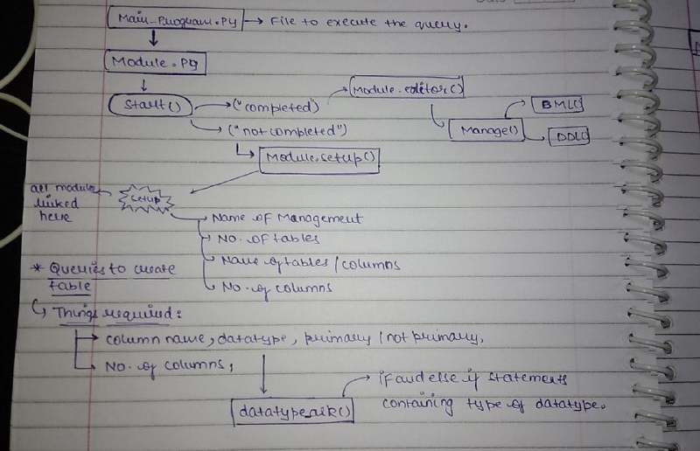

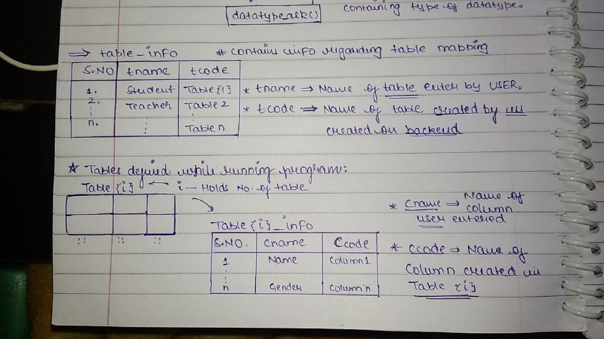

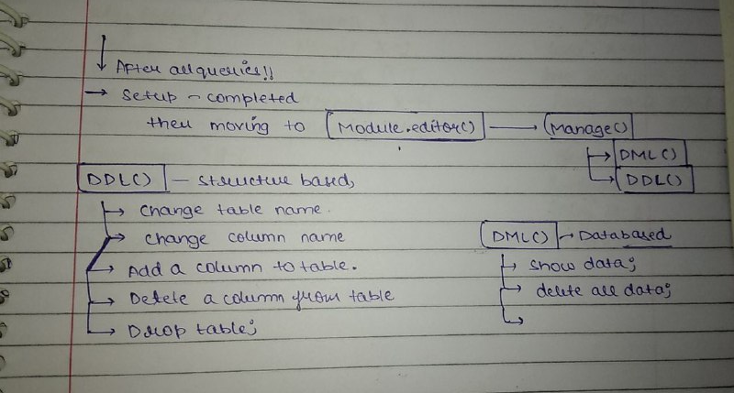

Coding
Main_Program.py
import Module as mo
import mysql.connector as con
path=con.connect(host=”localhost”,user=”root”, passwd=”12345”,database=”user1”)
cur=path.cursor()
cur.execute(“drop database user1”)
cur.execute(“create database user1”)
mo.start()

Module.py
import Module
import mysql.connector as con
path=con.connect(host=”localhost”, user=”root”, passwd=”12345”,database=”user1”)
cur=path.cursor()
global status
global manager
def start():
status=””:
if status == “”:
print(“Hello User, Welcome to DBMS”)
Module.setup()

def Editor():
print(“\nHello User, Welcome to manager”)
print(“!! Setup Already completed...”,”\t Procedding to Management... !! “)
Module.Manage()

def setup():
status=””
manager=input(“Please Enter the Name of the Management : “)
tno=int(input(“\n\nPlease Enter the Number of Tables : “))
cur.execute(“create table Table_info(Table_Name
varchar(30),Table_id varchar(30))”)
for i in range(1,tno+1):
name=input(f”Input the name of table{i} : “)
cur.execute(f”insert into table_info values(‘{name}’,’table{i}’)”)
cur.execute(f”create table table{i}_info(Sno int,column_name
varchar(30),column_id varchar(30),datatype varchar(30))”)
cno= int(input(“\nHow many columns you want : “))
for j in range(1,cno + 1):
c_name=input(f”\nEnter the name of Column{j} : “)
m=Module.datatype_ask()
rec=j,c_name,f”cname{j}”,m
z=f”cname{j}”
cur.execute(f”insert into table{i}_info
values({j},’{c_name}’,’{z}’,’{m}’)”)
print(“\nSetup Completed !! Congo !!”)
status=”completed”
Module.Editor()

def datatype_ask():
print(“What Type of Data will it Hold:-“)
print(“1. Character (Recomended for Alpha Numerical Values)”,”2.
Integer”)
print(“3. Fractional (Decimal)”,”4. Date 5. Time”)
n=int(input(‘Enter the 14orresponding number : ‘))
dtype=””
if n==1:
dtype=’varchar(100)’
elif n==2:
dtype=’int’
elif n==3:
dtype=’float’
elif n==4:
dtype=’date’
elif n==5:
dtype=’time’
else:
print(“Invalid Query”)
return dtype

def table_no():
cur.execute(“select Table_Name from Table_info”)
num=0
for i in cur:
num+=1
for j in i:
print(j,end=”\t”)
print(num)
table_no=int(input(“Please Enter the Corresponding No. to access a
table : “))
return table_no

def Manage():
print(“\n Choose the type of 16orrespondi : “)
print(“1. DDL Options 2.DML options”)
query = int(input(“Enter the 16orresponding number : “))
if query==1:
Module.DDL()
elif query==2:
Module.DML()
else:
print(“Invalid Query”)

def DDL():
print(“\n What Option do you want to execute ?? “)
print(“1. Change Table Name”,”2. Drop table”)
print(“3. Reset Software”,”\n”)
n=int(input(‘Enter the 17orresponding number : ‘))
if n==1:
table_no=Module.table_no()
new_name=input(“Enter the New Name of table : “)
cur.execute(f”update table table_info set table_name={new_name}
where table_id=’table{table_no}’”)
cur.commit()
print(“Table Name changed Successfully !! “)

elif n==2:
table_no=Module.table_no()
cur.execute(“drop table table{table_no}_info”)
cur.execute(“delete from table_info where
table_id=table{table_no}”)
elif n==3:
cur.execute(“drop database user1”)
cur.execute(“create database user1”)
print(“Software Reset !! \t Please run the Setup Again !!”)
else:
print(“Invalid Query”)

def DML():
print(“What Option do you want to execute ?? “,”\n”)
print(“1. View Data”,”2. Delete all Data”,”\n”)
n=int(input(‘Enter the 18orresponding number : ‘))
if n==1:
table_no=Module.table_no()
option=cur.execute(f”select * from table{table_no}_info”)
print(option)
elif n==2:
table_no=Module.table_no()
cur.execute(f”delete from table{table_no}_info”)
print(“Query Executed !! “)
else:
print(“Invalid Query”)

Execution and Output
start(), setup(), datatype_ask()
- 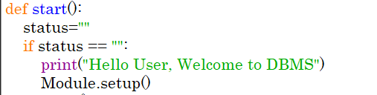
- 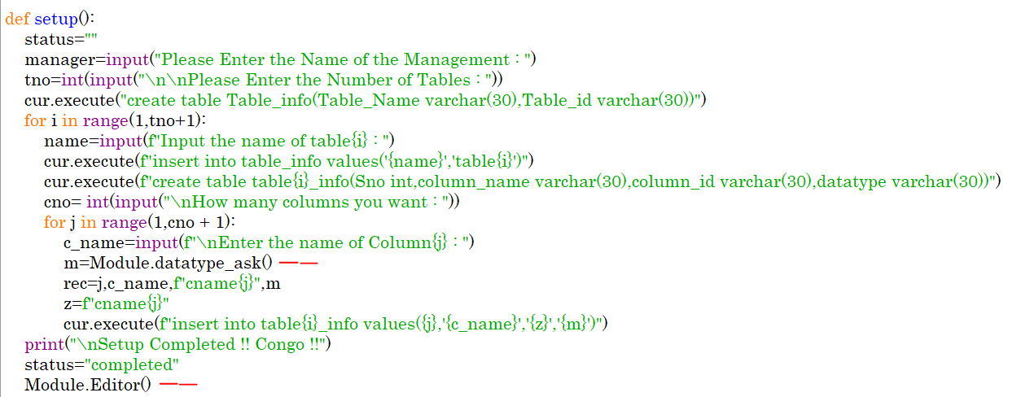

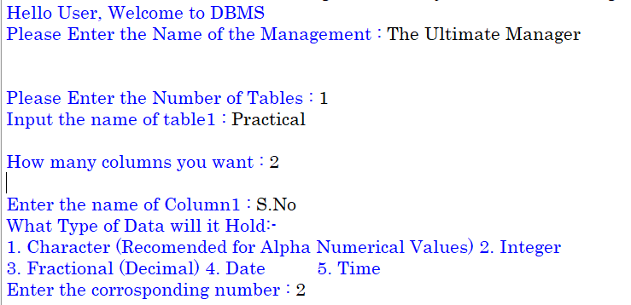
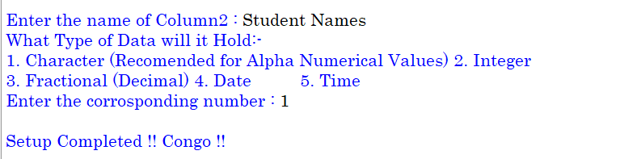

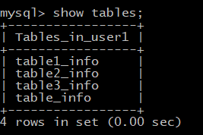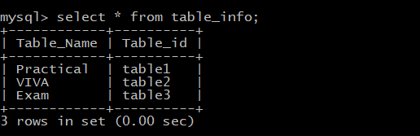

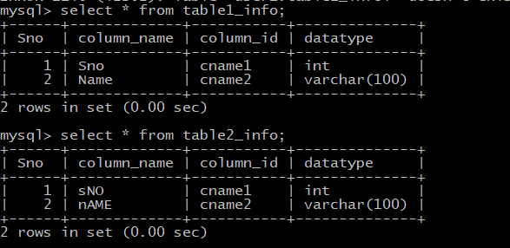
3)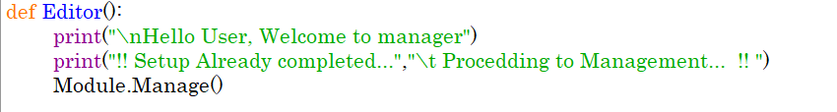
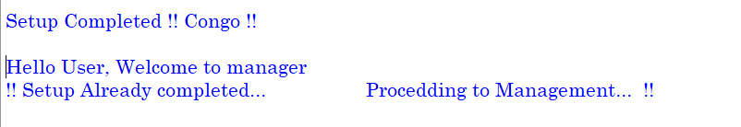

4) 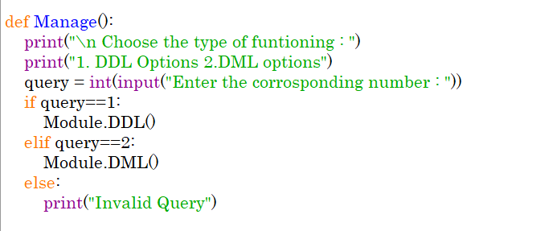
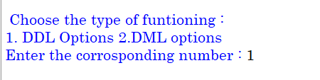
5) 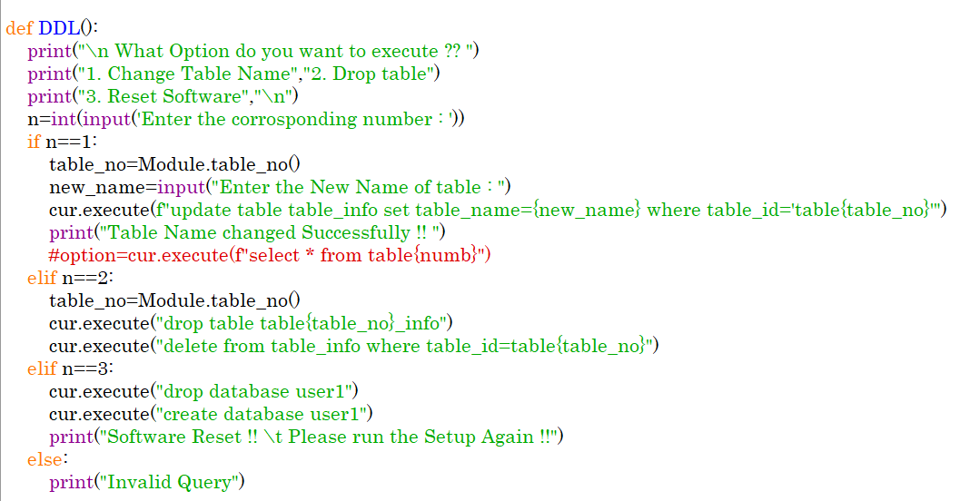
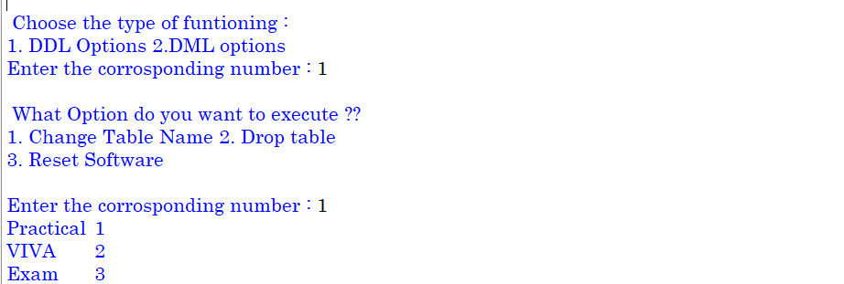
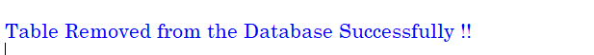
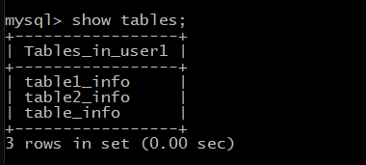

6)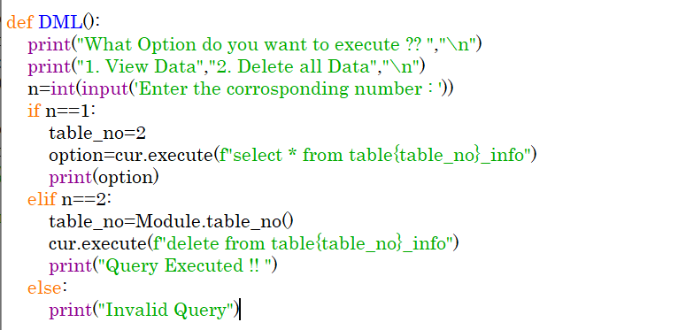
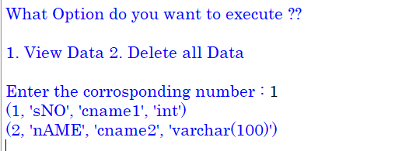

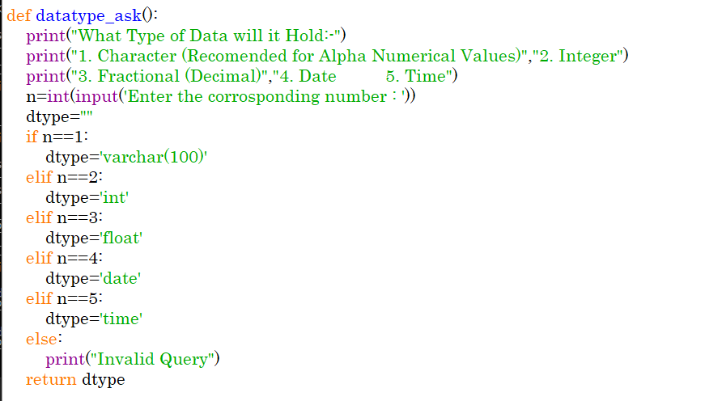

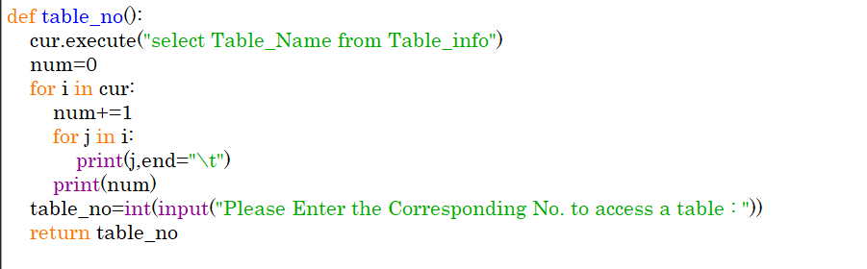

Hardware Requirements

 | OPERATING SYSTEM | Windows 7 and Above
 | PROCESSOR | Pentium(Any) or AMD  Athalon(3800+ - 4200+ DUAL Core)
 | MOTHERBOARD | 1.845 or 915,995 for Pentium or MSI
 | RAM | 512MB+
 | HARD DISK | SATA 40 GB or Above

Software Requirements

- Windows OS
- Python
- MySQL

BIBLOGRAPHY

- Sumita Arora/Preeti Arora
(Dhanpat Rai Publications)

- Computer Science Teacher – MR. Nadeem Sir

- www.google.com, www.w3schools.com

- www.python.org.in, www.mysql.org

